# Iman Davenport's correction of Friedman's rank sum test

AvgRanks of **MAUC**

|  |  |  |  |  |  |  |  |  |  |
| --- | --- | --- | --- | --- | --- | --- | --- | --- | --- |
| **AL.LB** | **AL.ARF** | **AL.ARFre** | **OALE** | **CALMID** | **LB** | **BOLE** | **MOOB** | **ARF** | **ARFre** |
| **6.87** | **7.67** | **8.20** | **7.93** | **3.00** | **2.20** | **5.20** | **6.53** | **3.40** | **4.00** |

data: dataMAUC

Corrected Friedman's chi-squared = 16.581, df1 = 9, df2 = 126, p-value < 2.2e-16

Nemenyi test

data: dataMAUC

Critical difference = 3.5548, k = 10, df = 140

plotCD(results.matrix=dataMAUC, alpha=0.05)

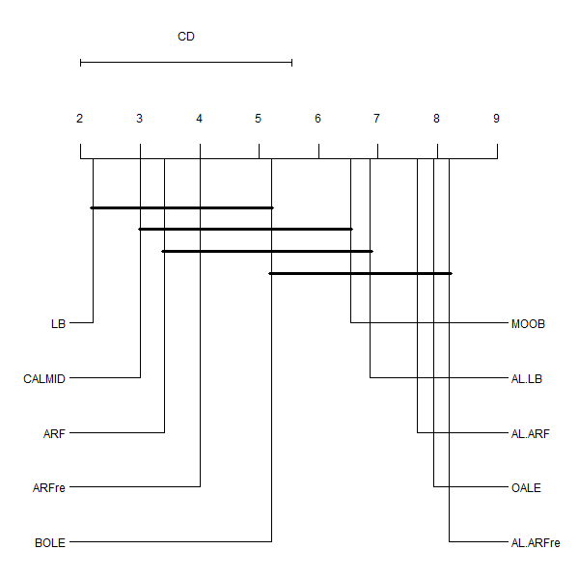

# **Iman Davenport's correction of Friedman's rank sum test**

AvgRanks of **Recall**

|  |  |  |  |  |  |  |  |  |  |
| --- | --- | --- | --- | --- | --- | --- | --- | --- | --- |
| **AL.LB** | **AL.ARF** | **AL.ARFre** | **OALE** | **CALMID** | **LB** | **BOLE** | **MOOB** | **ARF** | **ARFre** |
| **5.60** | **7.97** | **8.30** | **7.57** | **1.73** | **2.80** | **5.10** | **5.77** | **5.33** | **4.83** |

data: dataRecall

Corrected Friedman's chi-squared = 13.426, df1 = 9, df2 = 126, p-value = 6.661e-15

Nemenyi test

data: dataRecall

Critical difference = 3.5548, k = 10, df = 140

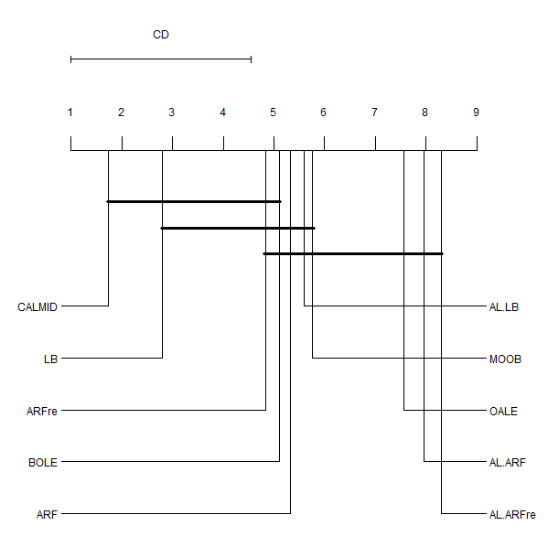

# **Iman Davenport's correction of Friedman's rank sum test**

AvgRanks of **FPR100**

|  |  |  |  |  |  |  |  |  |  |
| --- | --- | --- | --- | --- | --- | --- | --- | --- | --- |
| **AL.LB** | **AL.ARF** | **AL.ARFre** | **OALE** | **CALMID** | **LB** | **BOLE** | **MOOB** | **ARF** | **ARFre** |
| **5.77** | **7.33** | **7.9** | **8.33** | **2.17** | **2.17** | **5.3** | **7.1** | **4.6** | **4.33** |

data: dataFPR100

Corrected Friedman's chi-squared = 16.167, df1 = 9, df2 = 126, p-value < 2.2e-16

Nemenyi test

data: dataFPR100

Critical difference = 3.5548, k = 10, df = 140

plotCD(results.matrix=dataFPR100, alpha=0.05)



 